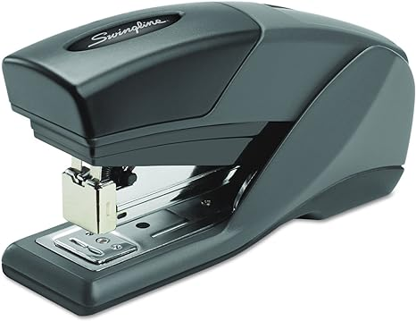

Lamy Stapler

The Lamy Stapler is a compact and efficient tool for your office needs. It features a modern design, sturdy construction, and provides a smooth stapling experience. Ideal for quick and reliable paper fastening, it’s a practical accessory for any workspace. 📎👍

5of30